Ideation Phase
Brainstorm & Idea Prioritization Template
Date | 27 JUNE 2025
Team ID | NM2025TMID06799
Project Name | Garage Management System in Salesforce -  Brainstorming & Idea Prioritization
Maximum Marks | 4 Marks

Prevent user deletion if assigned to an incident Template :
This guided project demonstrates how to prevent the deletion of users who are assigned to incidents within the system. It begins by creating test users and assigning incidents to them. A business rule is then created to enforce the restriction that prevents deletion if any incident is assigned to a user. This ensures important data is preserved and prevents accidental removal of users who are still linked to active work items.
The workflow also includes a test scenario to validate the behavior. First, a test is performed with an unassigned user to confirm that deletion is allowed when no assignments exist. Finally, an attempt is made to delete an unused user, verifying that the system permits this action without any errors. This process helps administrators maintain accurate user records while enforcing necessary safeguards.
Step-1: Team Gathering, Collaboration and Select the Problem Statement:
Team Collaboration
A Garage Management System in Salesforce is developed by a team working together. Each member has a specific role:
Project Manager – Plans the project and makes sure the work is completed on time.
Business Analyst – Talks to the garage owner, understands the requirements, and documents them.
Salesforce Admin – Creates objects, fields, page layouts, and automation using Salesforce setup.
Salesforce Developer – Builds custom features using Apex and Lightning components.
Tester (QA) – Tests the system, finds errors, and ensures everything works correctly.
Simple team workflow:
1. Business Analyst collects requirements.
2. Admin and Developer build the system.
3. Tester checks for errors.
4. Project Manager reviews and delivers to the client.
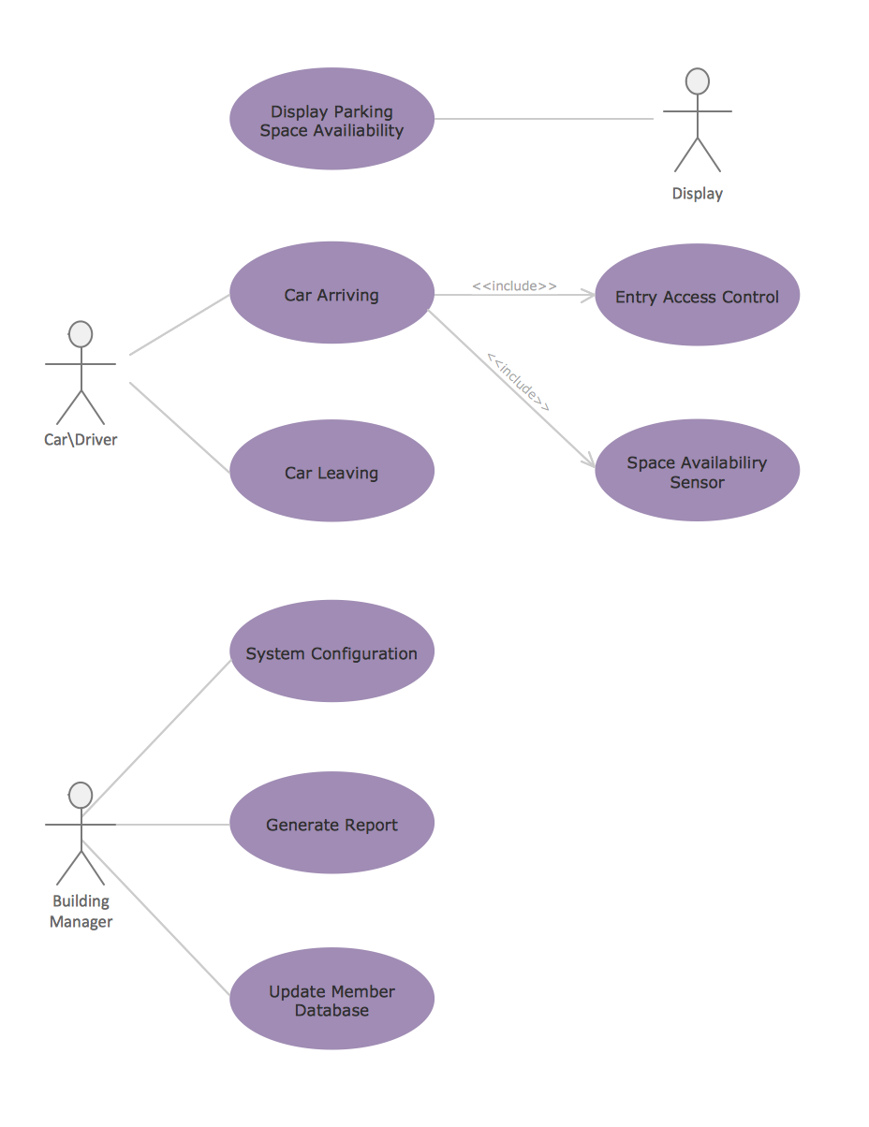

Step-2: Brainstorm, Idea Listing and Grouping:
The Garage Management System is designed to overcome challenges like manual appointment booking, long customer waiting time, difficulty in tracking service status, billing mistakes, and poor inventory control by offering features such as digital customer appointment scheduling, automatic job card creation, real-time service progress tracking, parts and stock management, accurate invoice generation, customer feedback collection, and analytical dashboards, which are organized into key functional groups—customer handling, vehicle service management, inventory/parts control, billing and payments, and reporting and analytics—to ensure smooth, fast, and efficient garage operations.
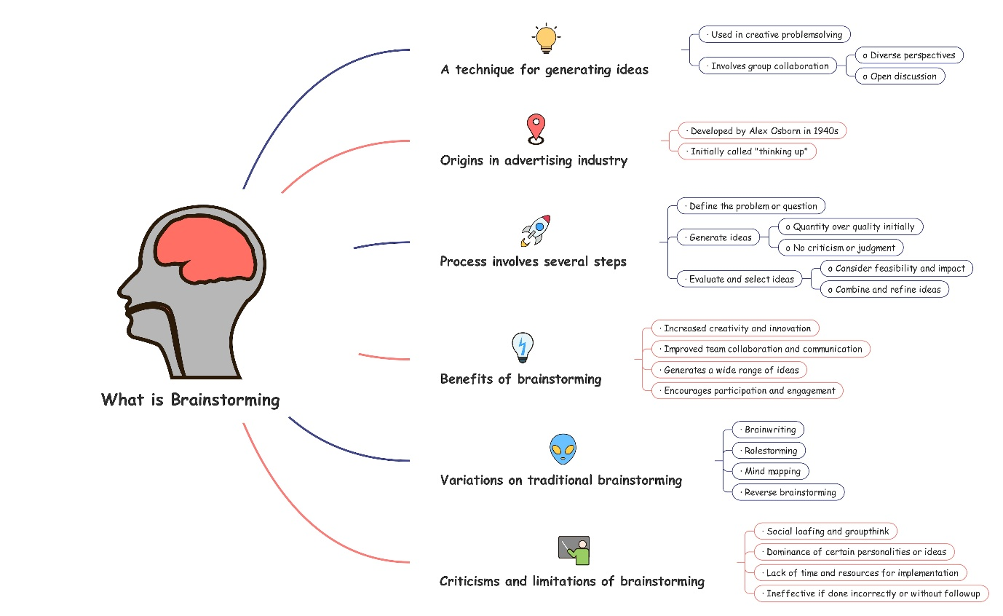

Step-3: Idea Prioritization:
Final Summary: In the Garage Management System, the development should begin with essential operational features such as customer and vehicle registration, appointment scheduling, job card management, inventory tracking, and billing because they form the core of daily garage activities. Once these are functional, workflow-enhancing features like staff assignment, customer notifications, and dashboard analytics should be added to improve efficiency and decision-making. Finally, customer-focused upgrades such as a customer portal, loyalty programs, and online payment integration can be introduced to enhance user experience and provide additional value.

